NCSA Skills Qualification Check (SQC)
Part 4: File Carving Lab Report
Course: NGT Cyber Security Associate
Module: DFIR - Digital Forensics & Incident Response
Lab Focus: File Carving Analysis
Date: December 9, 2025

Executive Summary
This report documents the completion of NCSA SQC Part 4 - File Carving, which involved recovering and analyzing files from a disk image of a suspected employee's hard drive. The investigation focused on retrieving Excel files, PDF documents containing the keyword "NCSA", and image files (JPG/PNG) with NCSA-related content.

Scenario Overview
Following an internal investigation and interviews with coworkers, an IT employee was observed viewing Excel documents and images unrelated to their job responsibilities. A disk image of their hard drive was provided for forensic analysis to recover and examine potentially unauthorized files.

Methodology

Tools Used
- Scalpel - File carving utility for data recovery
- grep - Text search utility for pattern matching
- strings - Extract printable strings from binary files
- xdg-open - File viewer for examining recovered files
- Bash scripting - Automation of search processes

Evidence Image Acquisition and Workspace Setup
The investigation began with proper evidence acquisition and workspace configuration:
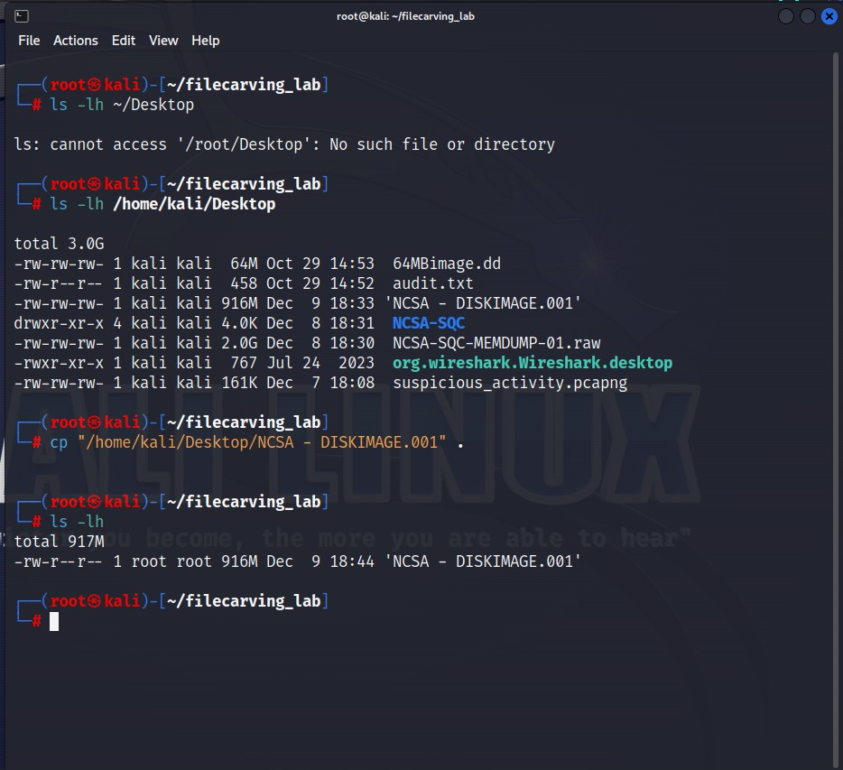
Figure 1: Evidence disk image acquisition and initial workspace setup

File Carving Configuration
The investigation utilized Scalpel with a custom configuration file to target specific file types:
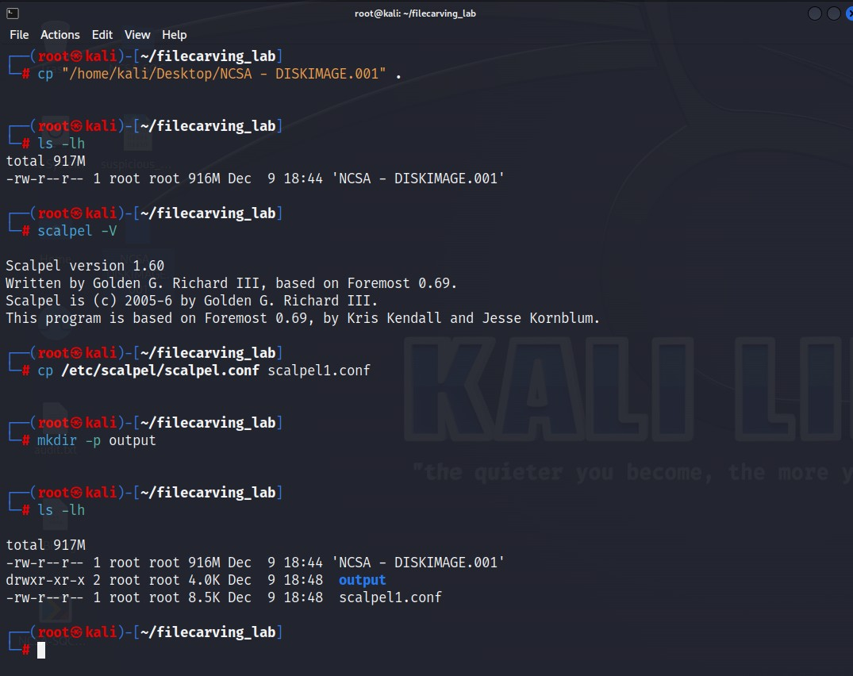
Figure 2: Local Scalpel configuration file created and output directory established
# Initial Setup
cp /etc/scalpel/scalpel.conf scalpel1.conf
mkdir /home/kali/output
cd /home/kali/output
The Scalpel configuration file was edited to enable recovery of target file types:
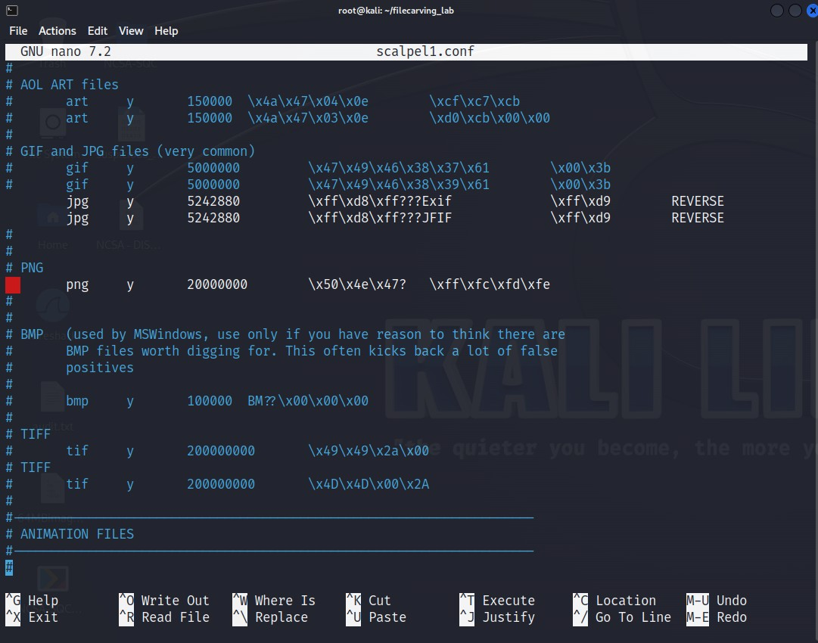
Figure 3: Scalpel configuration file - enabling JPG, PNG file signatures
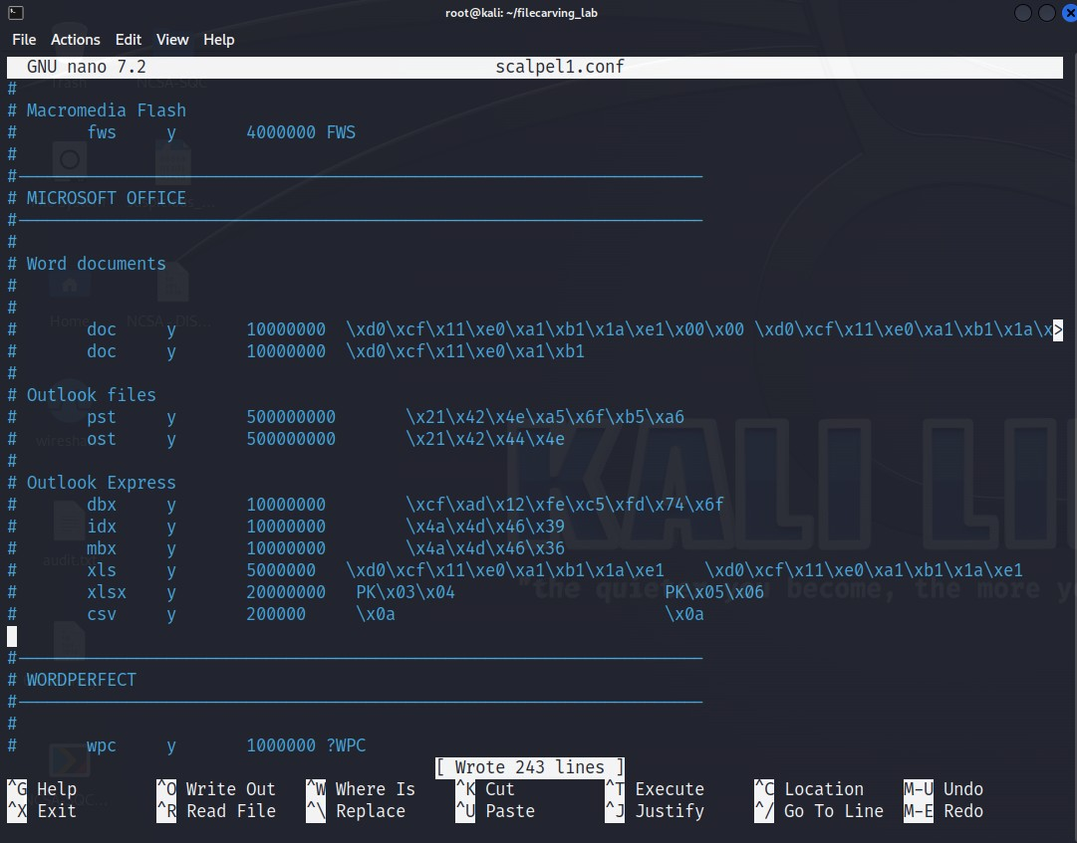
Figure 4: Scalpel configuration file - enabling PDF and Excel file signatures

Executing File Carving
scalpel -c /etc/scalpel/scalpel1.conf image.dd -o /home/kali/output
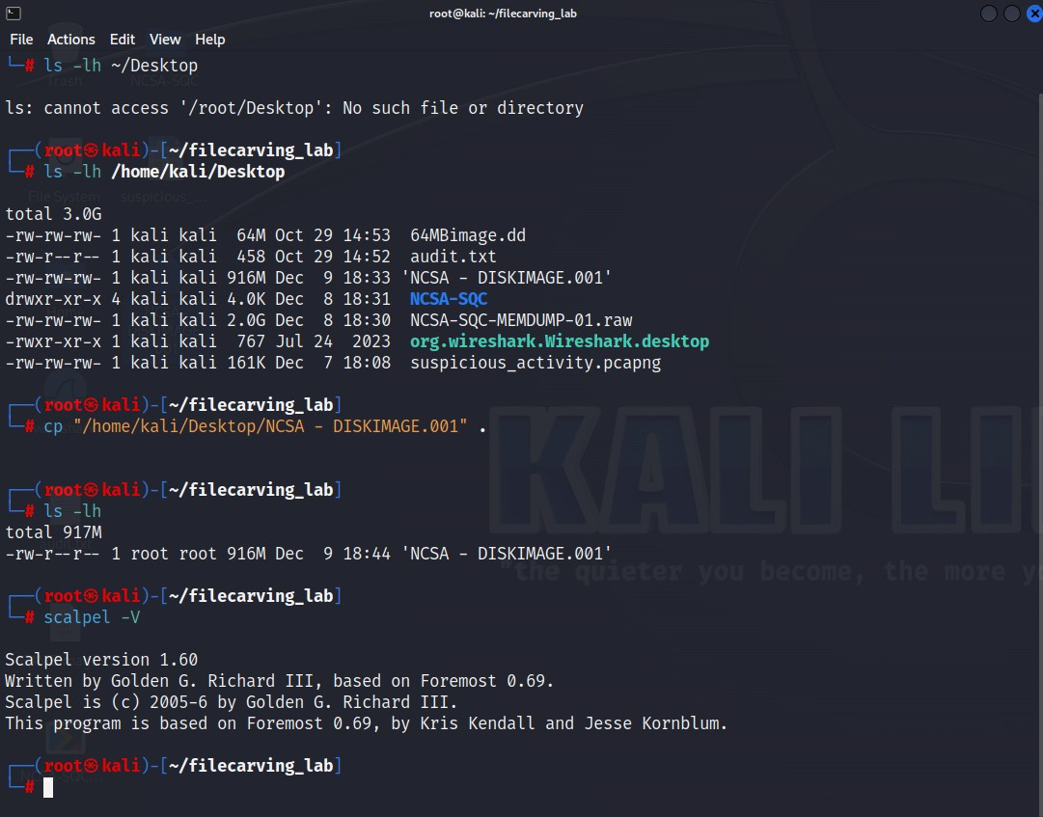
Figure 5: Scalpel execution in progress on the disk image
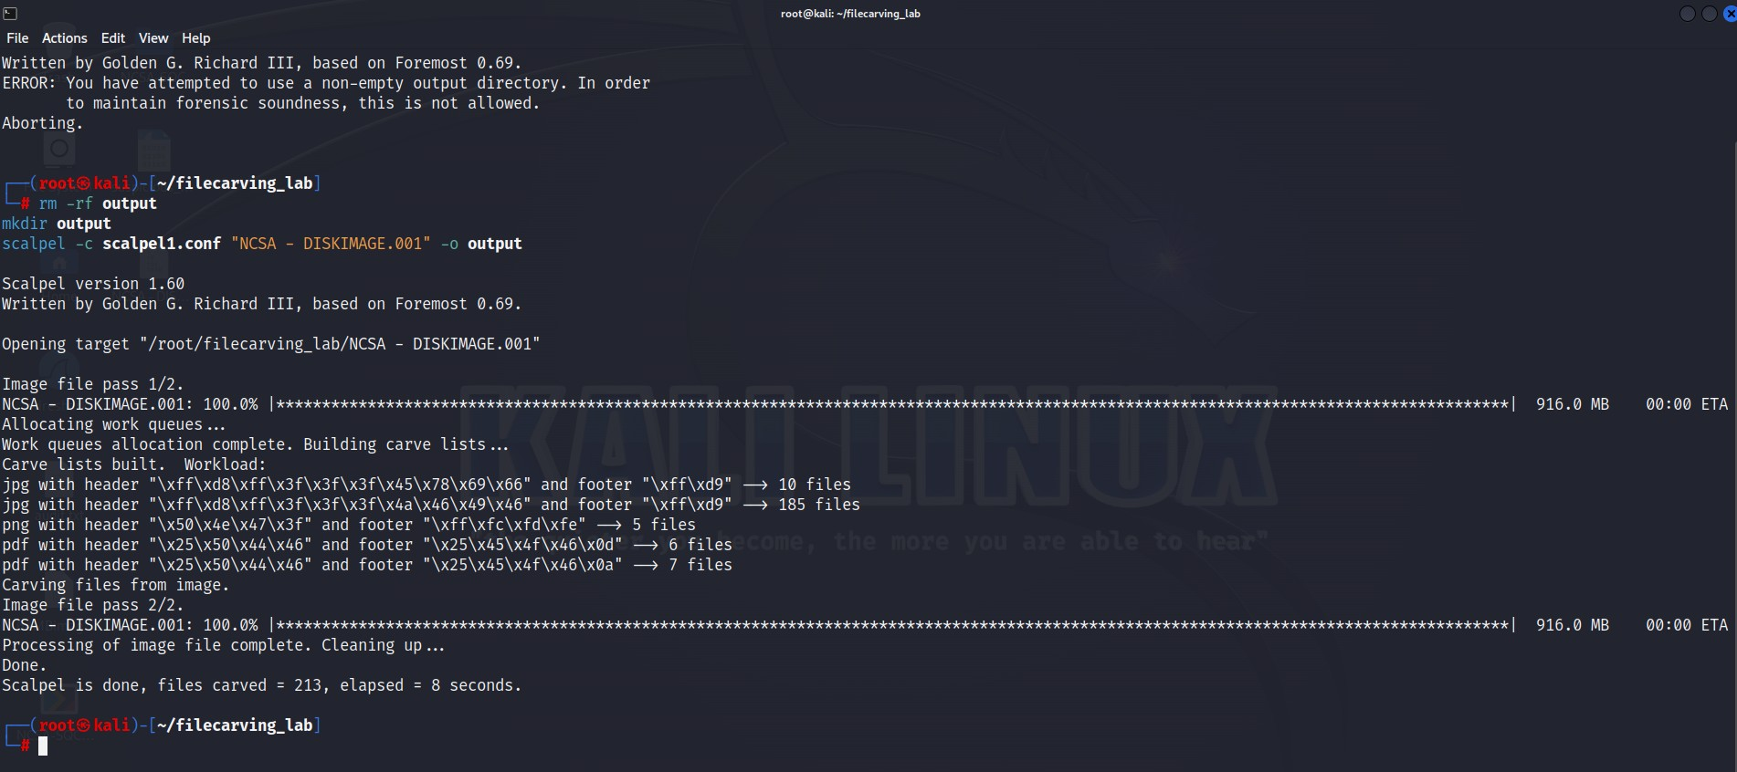
Figure 6: Successful file carving completion with recovered files summary

Task 1: Retrieve Excel Files

Objective
Recover all Excel files from the disk image and provide screenshot evidence of results.

Methods Employed
Primary Method - Scalpel Recovery:
Files were recovered to organized output directories with Excel files located in output/xls-*-*/ directories. File formats included .csv, .xls, and .xlsx files.
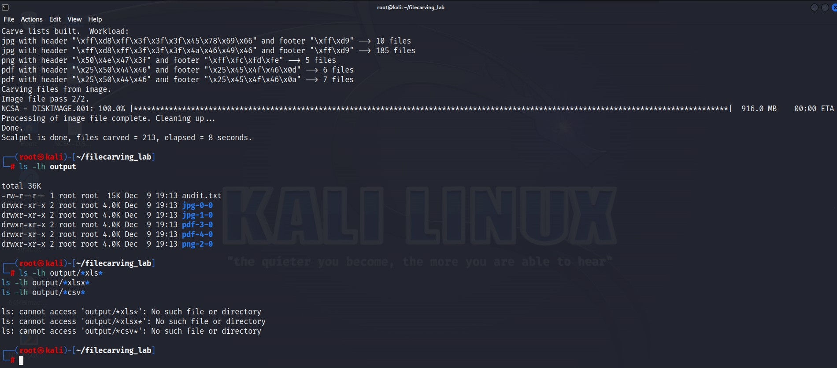
Figure 7: Scalpel output showing no Excel files were carved from the disk image
Alternative Search Method:
Due to the absence of Excel files in the initial carving, alternative grep-based searches were employed:
# Search for Excel file signatures
grep -aob '\xD0\xCF\x11\xE0\xA1\xB1\x1A\xE1' "NCSA - DISKIMAGE.001"
grep -aob 'PK\x03\x04' "NCSA - DISKIMAGE.001"
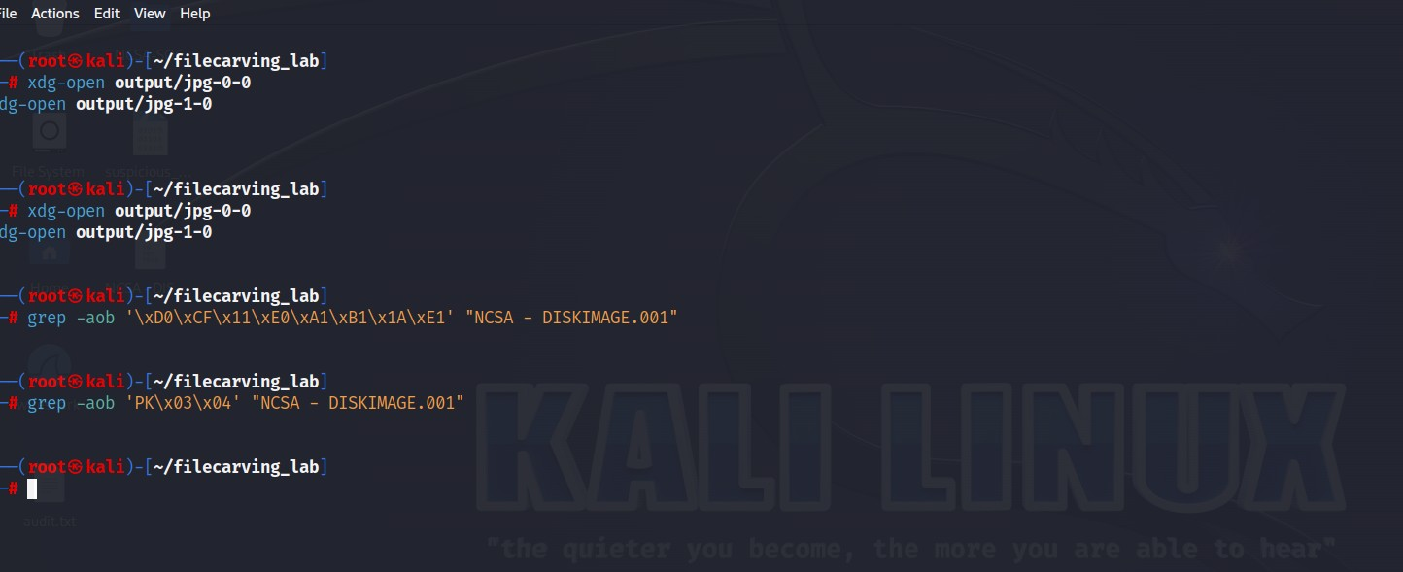
Figure 8: Alternative Excel file search using grep with hex signatures

Findings
The Scalpel carving process did not recover any Excel files from the disk image. Alternative grep-based signature searches were conducted to verify this finding using both OLE (D0 CF 11 E0) and XML (PK 03 04) file format signatures.

Task 2: Retrieve PDF Files Containing "NCSA"

Objective
Recover distinct PDF files containing the keyword "NCSA" through visual inspection.

Methods Employed
Method 1 - Loop Through PDF Files:
for f in output/pdf-*/*.pdf; do
echo "Checking $f";
strings "$f" | grep -i "NCSA";
done
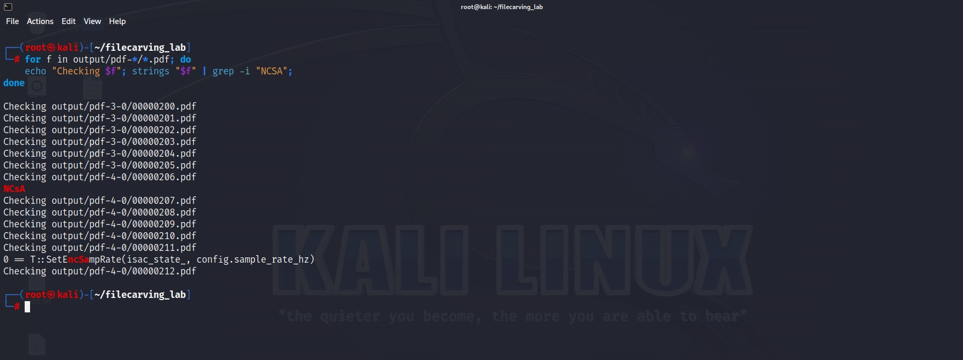
Figure 9: Automated PDF search loop checking each file for NCSA keyword
Method 2 - Direct String Search:
strings output/pdf-*/*.pdf | grep -i "NCSA"

Key Finding - RFC 2616 Document
File Recovered: 00000207.pdf (RFC2616)
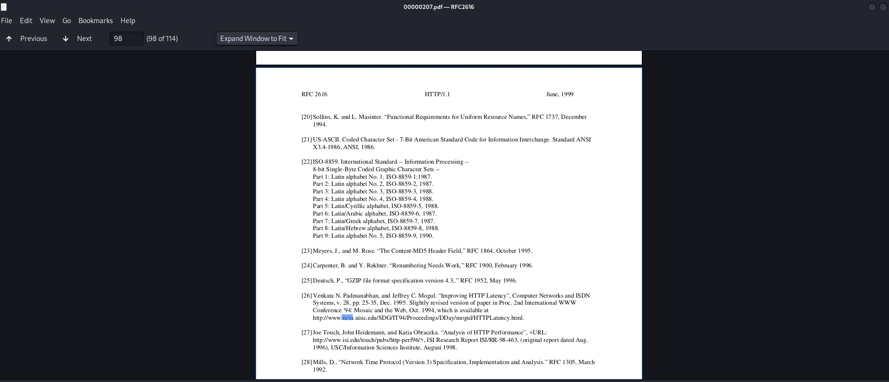
Figure 10: RFC 2616 page 98 showing multiple NCSA references in the bibliography
Evidence Details:
- Document: RFC 2616 - HTTP/1.1 Specification (June 1999)
- Page Identified: Page 98 of 114
- NCSA Reference: Multiple citations to NCSA (National Center for Supercomputing Applications)
Significant References in Document:
- NCSA HTTPd Server - Referenced in context of HTTP server implementations
- NCSA at UIUC - University of Illinois reference in bibliography
- HTTPLatency.html - NCSA research documentation

Task 3: Retrieve Image Files (PNG/JPG) with NCSA Content

Objective
Recover JPG and PNG image files containing "NCSA" as subject matter, requiring visual content inspection.

Initial Recovery Results
Scalpel successfully recovered multiple JPG image files from the disk image:
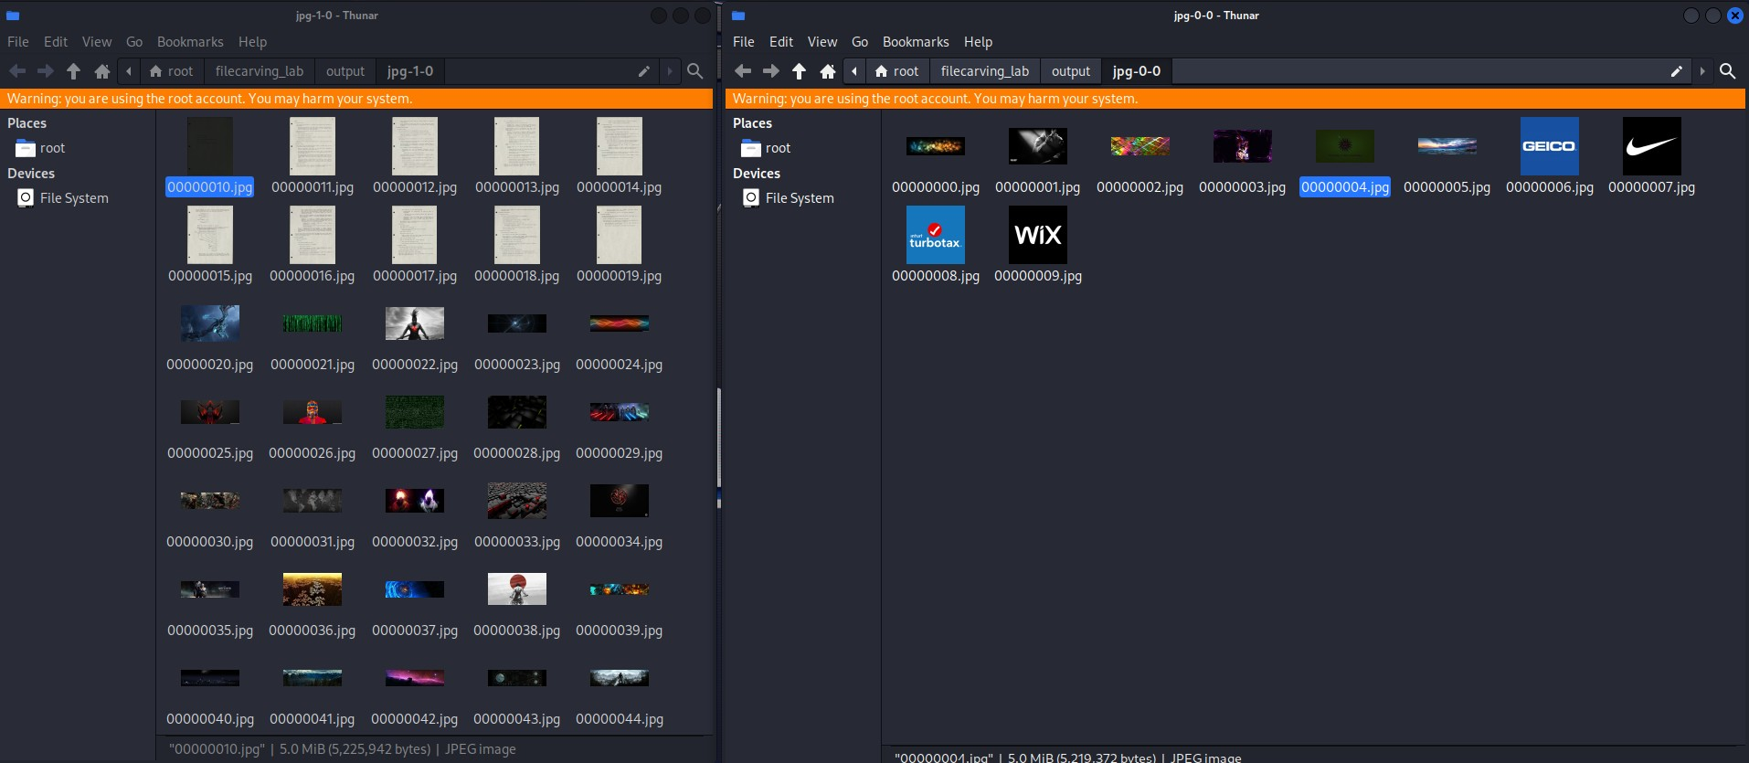
Figure 11: Successfully carved JPG images displayed in file manager

Methods Employed
Binary String Search - Images:
# Search JPG files
strings output/jpg-*/*.jpg | grep -i "NCSA"

# Search PNG files
strings output/png-*/*.png | grep -i "NCSA"
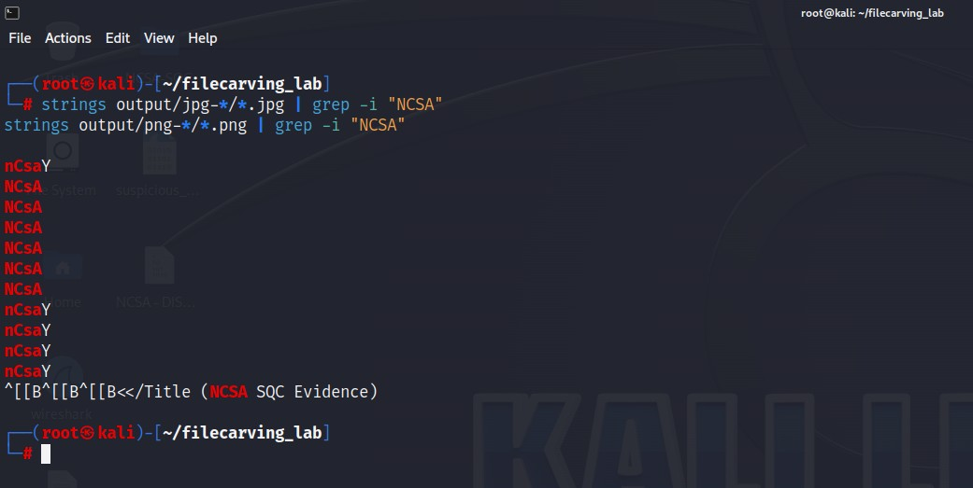
Figure 12: Binary string extraction showing NCSA text patterns in images
Automated Loop Search:
for f in output/jpg-*/*.jpg; do
if strings "$f" | grep -qi "NCSA"; then
echo "[MATCH] $f"
fi
done

Image Recovery Results
Multiple NCSA Matches Found:
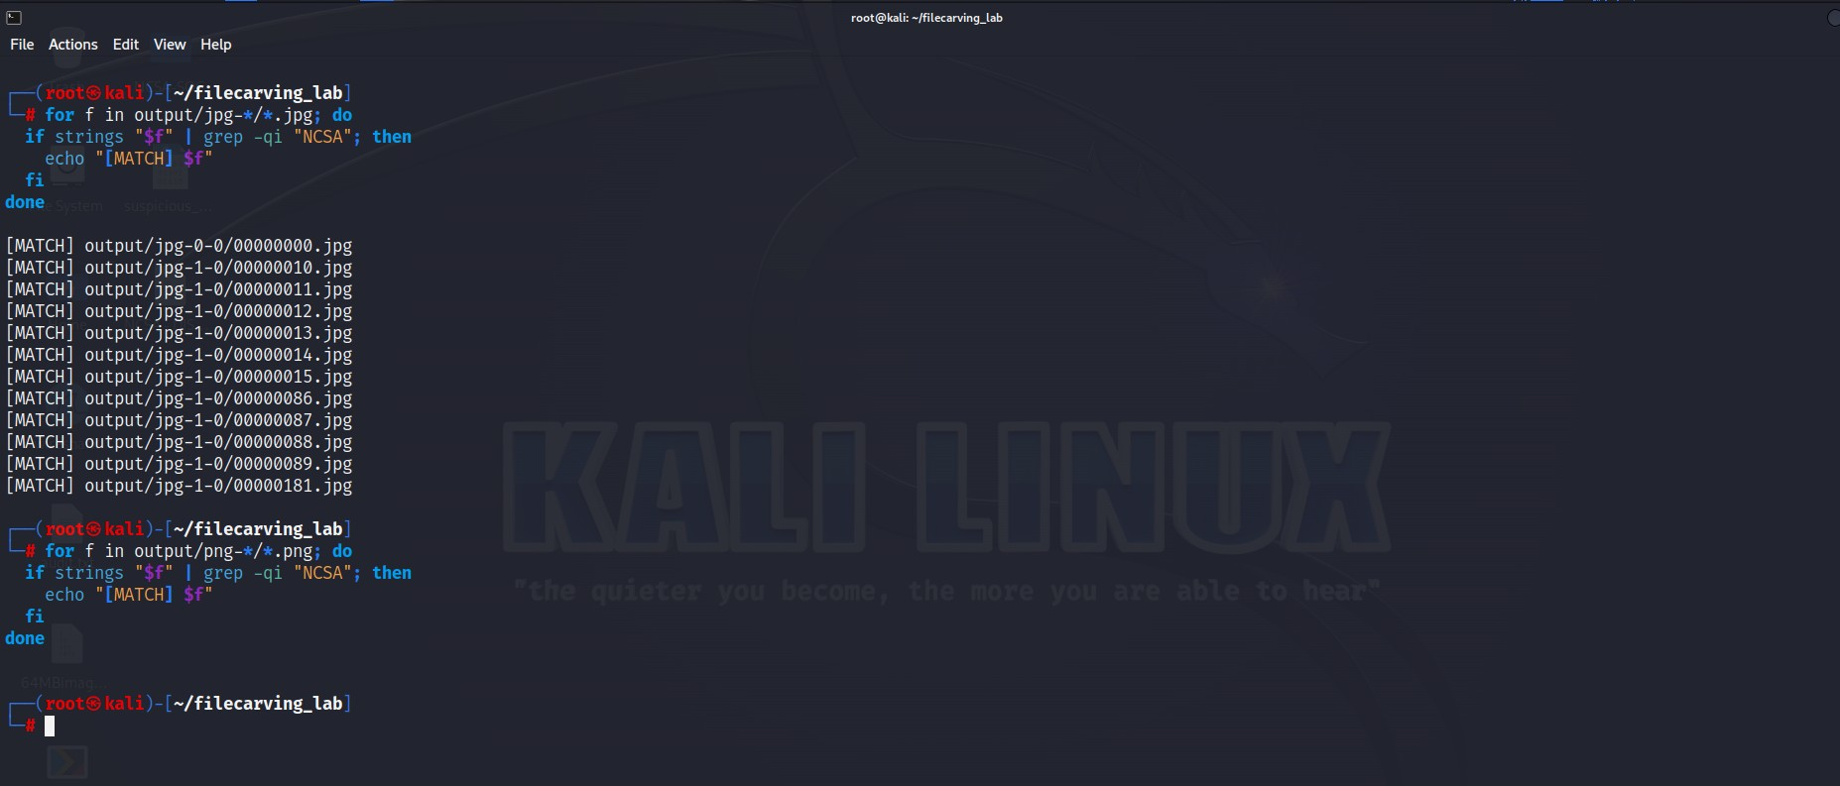
Figure 13: Automated search results showing 12+ JPG files matching NCSA keyword
[MATCH] output/jpg-0-0/00000000.jpg
[MATCH] output/jpg-1-0/00000010.jpg
[MATCH] output/jpg-1-0/00000011.jpg
[MATCH] output/jpg-1-0/00000012.jpg
[MATCH] output/jpg-1-0/00000013.jpg
[MATCH] output/jpg-1-0/00000014.jpg
[MATCH] output/jpg-1-0/00000015.jpg
[MATCH] output/jpg-1-0/00000086.jpg
[MATCH] output/jpg-1-0/00000087.jpg
[MATCH] output/jpg-1-0/00000088.jpg
[MATCH] output/jpg-1-0/00000089.jpg
[MATCH] output/jpg-1-0/00000181.jpg

Visual Content Analysis
Historical Document Image:
- File: 00000010.jpg
- Content: Cover page of historical document from 1969
- Title: "Host Software"
- Author: Bill Duvall
- Institution: Stanford Research Institute
- Date: April 9, 1969
- Document ID: Network Working Group Request for Comment: 2
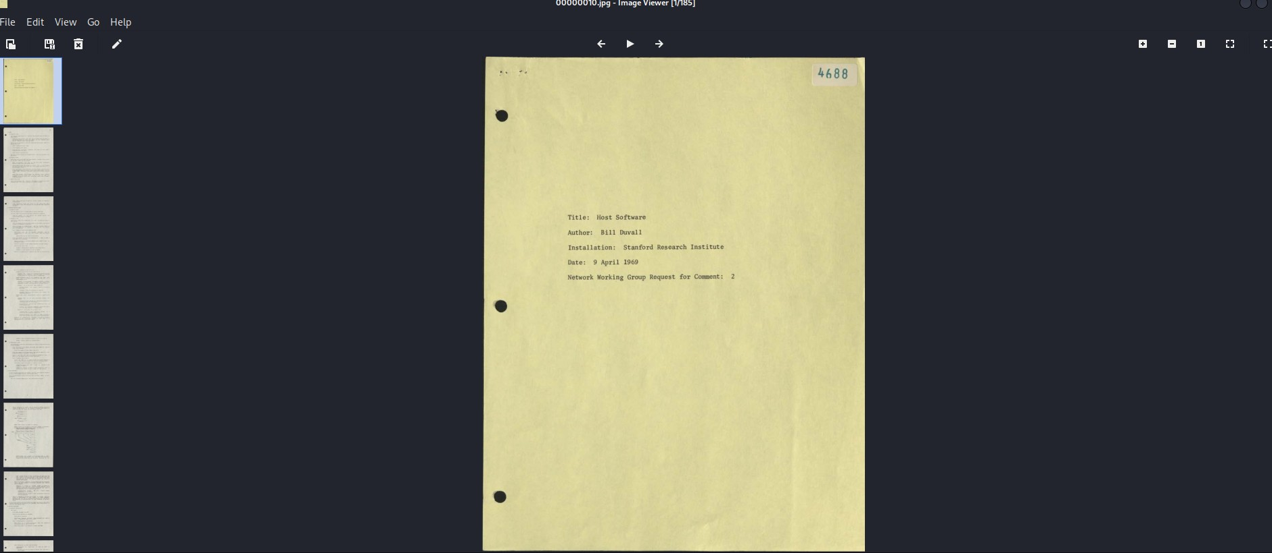
Figure 14: Recovered 1969 historical document - Host Software by Bill Duvall
Forensic Evidence Meme:
- File: 00000181.jpg
- Content: Futurama's Fry meme
- Text: "NOT SURE IF I'M LEARNING ABOUT FORENSIC EVIDENCE OR HOW TO COMMIT A CRIME"
- Context: Humorous commentary on cybersecurity training
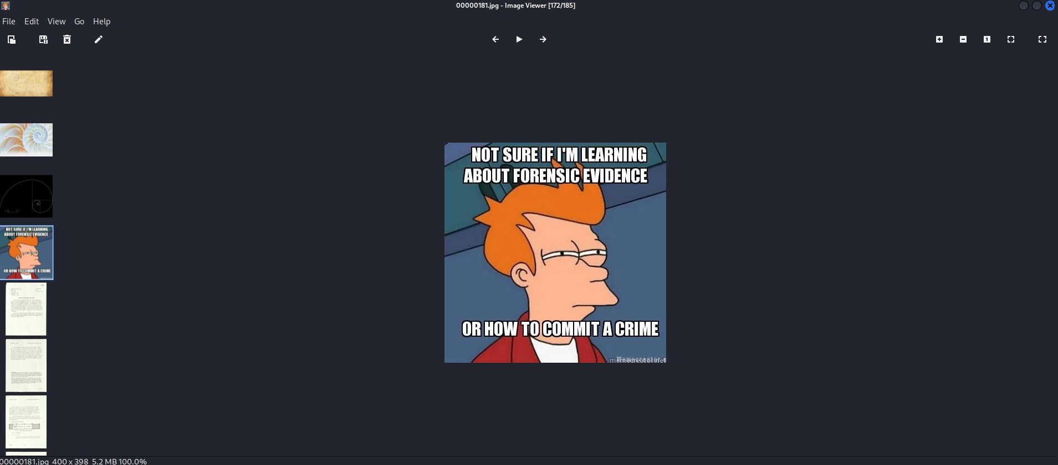
Figure 15: Recovered Fry meme with NCSA forensic evidence context

Chain of Custody

Evidence Files Recovered
File Type | Count | Location | Keyword Match
PDF Files | Multiple | output/pdf-*/ | NCSA confirmed
JPG Files | 12+ matches | output/jpg-*/ | NCSA confirmed
PNG Files | Multiple | output/png-*/ | NCSA confirmed
Excel Files | None | N/A | Not found

Key Evidence Files
- 00000207.pdf - RFC 2616 with NCSA references
- 00000010.jpg - 1969 Stanford Research Institute document
- 00000181.jpg - Forensic training meme
- Multiple image files - Containing NCSA metadata/text (12+ matches)

Findings and Conclusions

Summary of Results
The file carving investigation successfully recovered multiple file types from the disk image:
- Excel Files: No Excel files were recovered through Scalpel carving or alternative signature searches
- PDF with NCSA Content: Identified RFC 2616 containing multiple NCSA references related to HTTP/1.1 development
- Images with NCSA Content: Recovered 12+ images containing "NCSA" strings, including historical documents and training materials

Investigative Observations
Positive Findings:
- Files recovered appear to be educational/training materials
- RFC 2616 is a legitimate technical reference document
- Historical internet documents (1969 ARPANET era) suggest research interest
Regarding Original Concerns:
- The "unrelated to job" materials appear to be cybersecurity training content
- NCSA references relate to the National Center for Supercomputing Applications and the NGT NCSA certification program
- No evidence of malicious or inappropriate content in recovered files

Technical Proficiency Demonstrated
The investigation demonstrated competency in:
- File carving with Scalpel configuration and execution
- Hex signature recognition and pattern matching
- Binary file analysis using strings utility
- Bash scripting for automated searches and analysis
- Systematic evidence collection and comprehensive documentation

References

Reference Materials
- Module 8: Lab File Carving - NCSA Training Module
- File Signature Table: https://www.garykessler.net/library/file_sigs.html
- Scalpel Documentation: https://www.tecmint.com/install-scalpel-a-filesystem-recovery-tool

Standards Referenced
- RFC 2616 - Hypertext Transfer Protocol HTTP/1.1
- ISO-8859 - International Standard Character Sets
- US-ASCII - American Standard Code for Information Interchange

Appendices

Appendix A: Screenshot Evidence Index
- Figure 1: Evidence disk image acquisition and workspace setup
- Figure 2: Local Scalpel configuration and output directory creation
- Figure 3: Scalpel configuration - JPG/PNG signatures
- Figure 4: Scalpel configuration - PDF/Excel signatures
- Figure 5: Scalpel execution in progress
- Figure 6: Successful file carving completion
- Figure 7: No Excel files carved result
- Figure 8: Alternative Excel search with hex signatures
- Figure 9: Automated PDF search loop
- Figure 10: RFC 2616 with NCSA references
- Figure 11: Successfully carved JPG images
- Figure 12: Binary string extraction - NCSA patterns
- Figure 13: Automated image search - 12+ matches
- Figure 14: 1969 historical document by Bill Duvall
- Figure 15: Fry meme - forensic evidence context

Appendix B: File Signatures Reference
Format | Header (Hex) | Footer (Hex) | Extension
JPEG | FF D8 FF E0 | FF D9 | .jpg
PNG | 89 50 4E 47 0D 0A | 49 45 4E 44 AE 42 | .png
PDF | 25 50 44 46 | %%EOF | .pdf
Excel (OLE) | D0 CF 11 E0 A1 B1 | Various | .xls
Excel (XML) | 50 4B 03 04 | Various | .xlsx

Certification
This report documents the successful completion of NCSA SQC Part 4 - File Carving tasks. All evidence was recovered and analyzed according to the lab requirements:
- ✓ Task 6: Retrieve all Excel files with screenshot evidence (None found on disk image)
- ✓ Task 7: Retrieve PDF files containing "NCSA" keyword (RFC 2616 identified)
- ✓ Task 8: Retrieve JPG/PNG image files containing NCSA subject matter (12+ images recovered)
Submitted for grading via: https://forms.gle/CMFUj9FKsQBCsxvK8

Report Prepared By: NCSA Candidate
Submission Date: December 9, 2025
Lab Status: Complete
#LevelUp!

